**Agent workflow test- will do retailer next**

We remove this as an option- we don’t need it for any office created- only the true offices we add – **Update on Backend – P1**

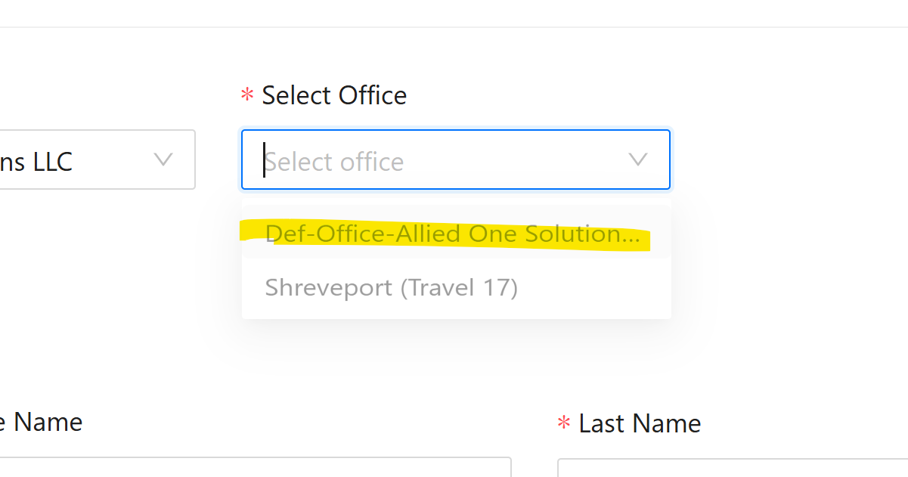

Remove shirt size **Both Frontend and Backend – P2**

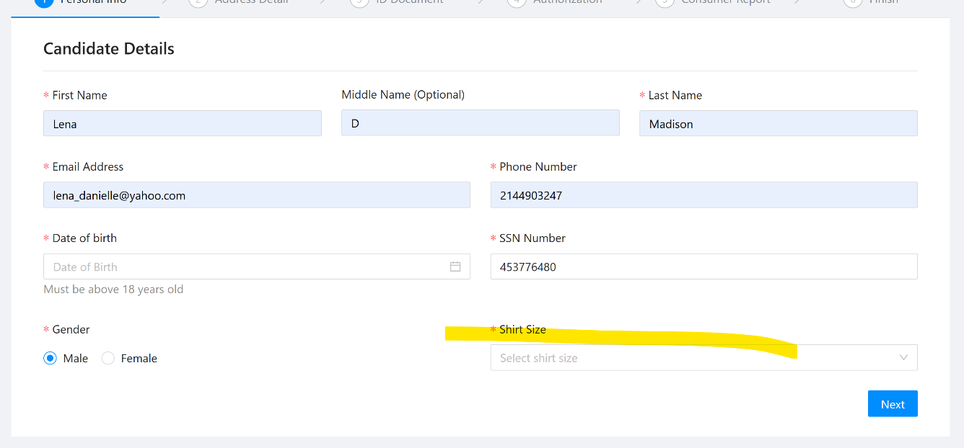

It doesn’t allow me to type in my DOB, once I hit enter the date disappears. The calender function is time consuming; I have to hit back 3+ times to get to the right year. Not the end of the world but if there is a better calender option then we can look at it later  
**Frontend – P2**

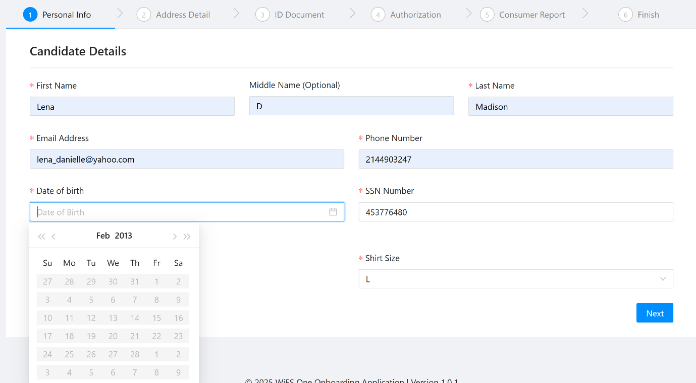

This should say SELLING location - please add the word.the option for ALL states should not be there- ONLY the Office locations we have linked to the IBO: **Frontend – P1**

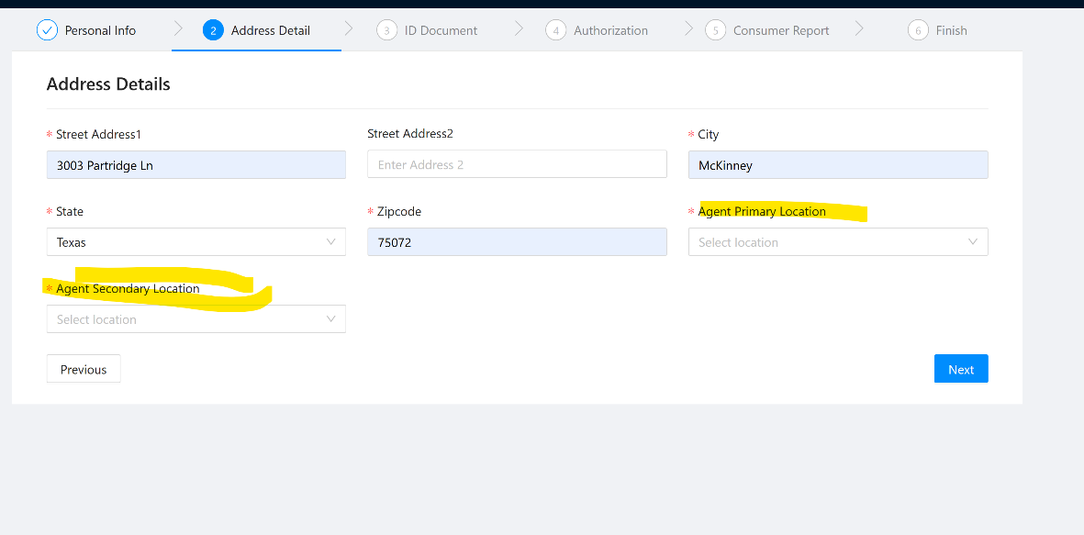

The yellow is the important prominet info on this page- click or drag to upload is secondary. NEed them to see what is and is not accepted first. Upload picture, should say upload headshot. It is also missing all the words and stuff in yellow that is on the onboarding formsite i sent over- 2nd photo. **Frontend – P1**

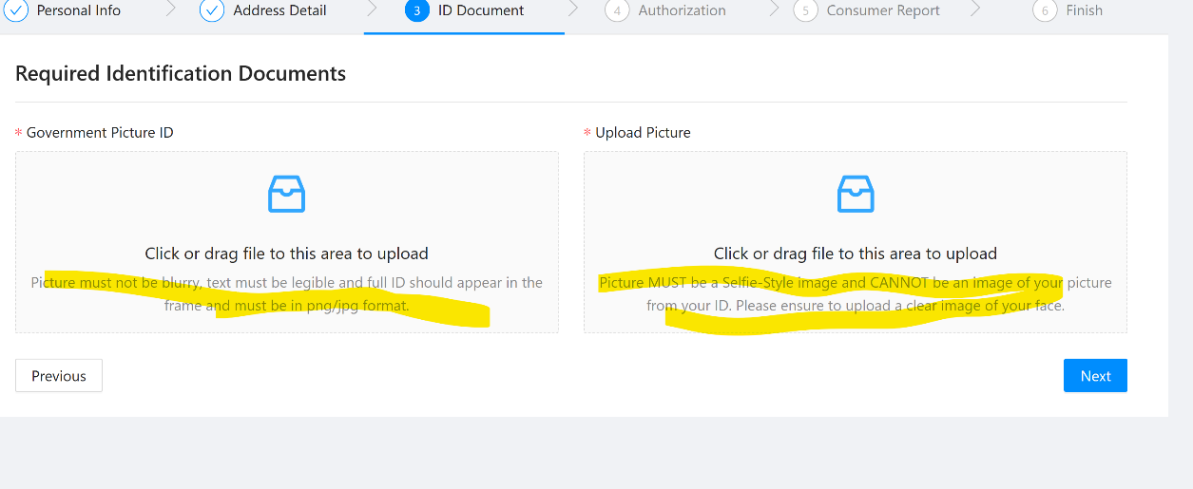

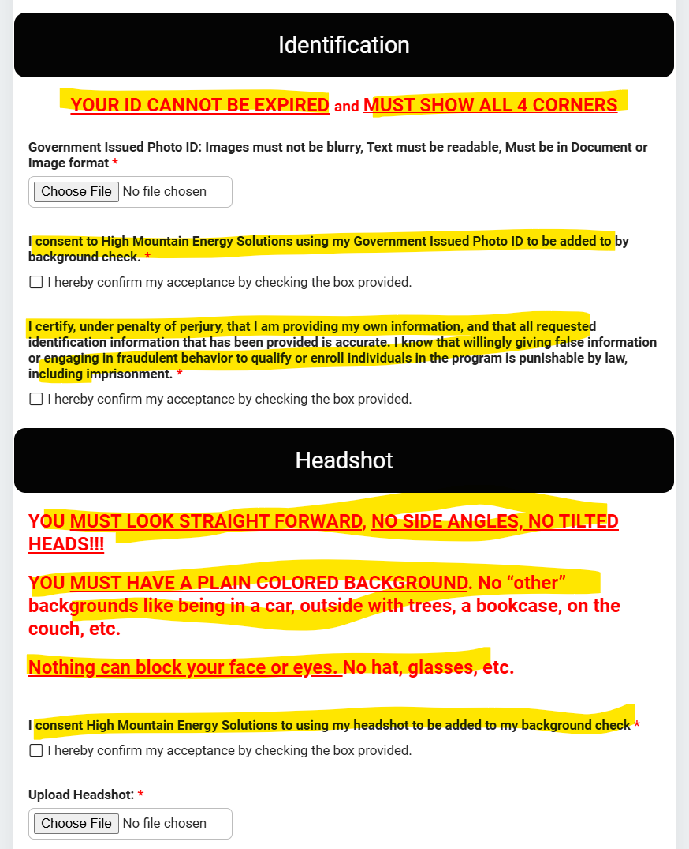

If campaign form is available- what does this mean

Why two options sign or click to sign- will ig change depending on who is filling this out

Same w confirm or submt?- said submit for me

Why do they have to upload a copy- doesnt the system auto retain it?

Add how they contact us: Energyonboarding@highmountaininc.com

After i hit submit, i must close the tab that opens and navigate back to the onboarding form- somewhat confusing- thats how it is now, i thought it would be more streamlined

The bullet points to follow the workflow need to be updated- to make it more clear on what to do **Both Frontend and backend – P1**

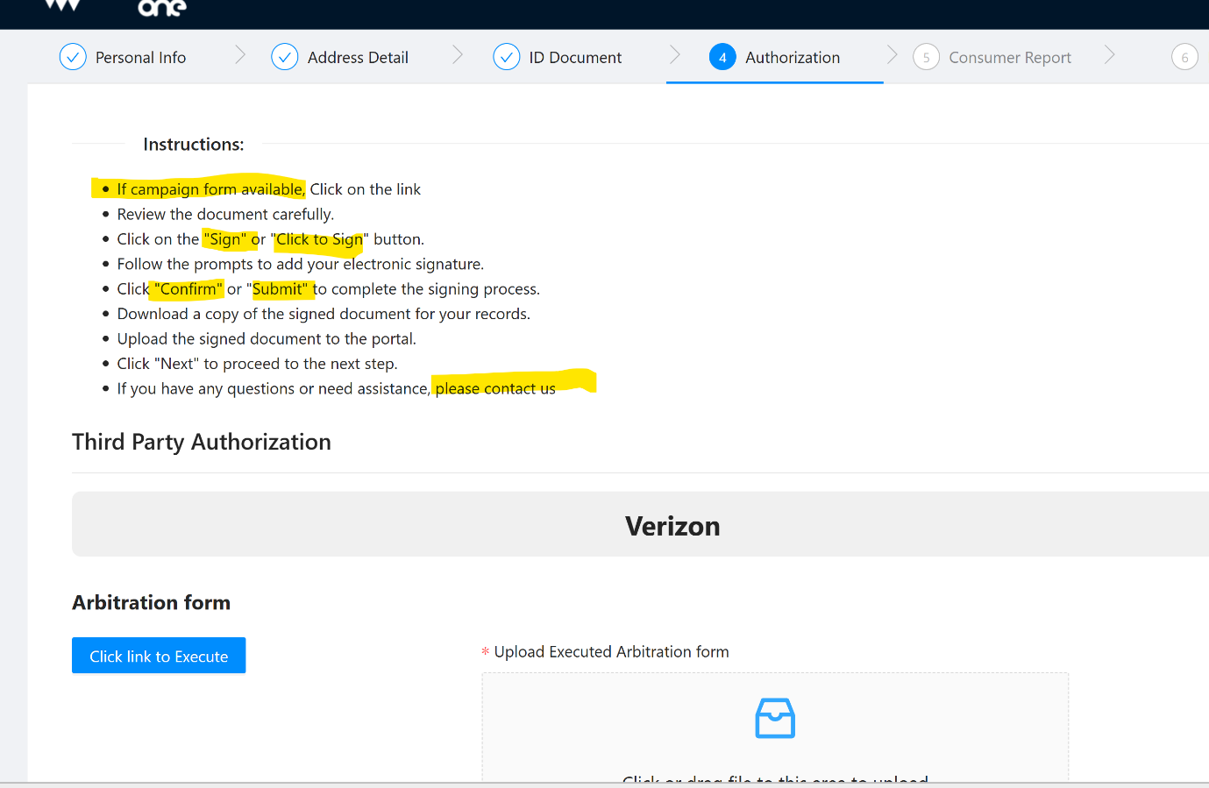

This campaign is under the name- high mountain marketing energy solutions- all hmm names should be high mountain energy solutions, it was like this on the  onboarding formsite i sent. **Frontend – p1**

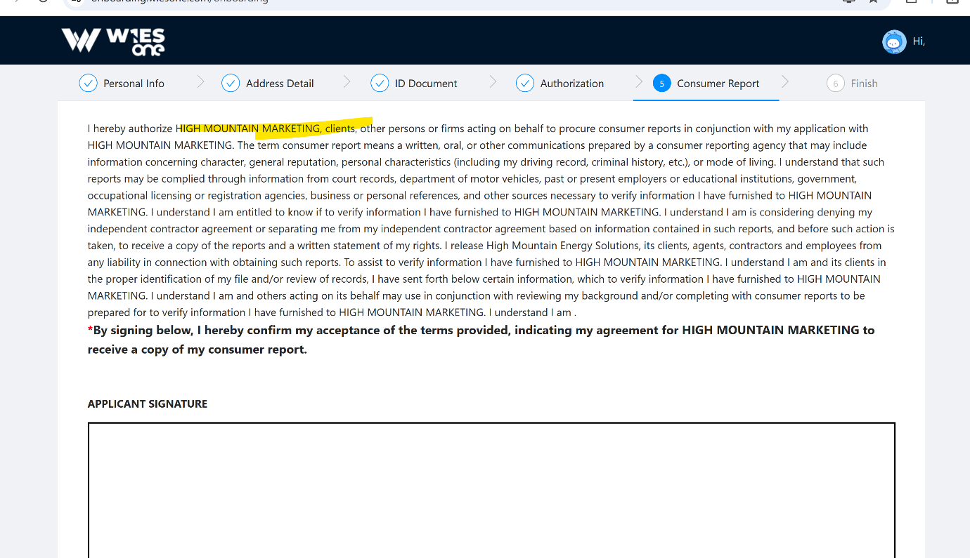

I didn’t get an email and i used [lena_danielle@yahoo.com](mailto:lena_danielle@yahoo.com) **Frontend - P2**

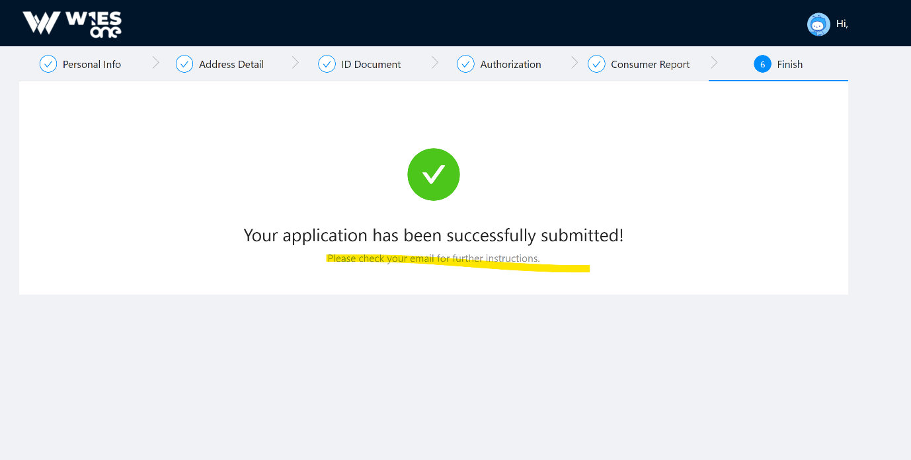

Can i have admin option to deactivate and office or delete it? – **Need Delete option**

IBO onboardingworkfow-  
 i cant test any more- i need to be able to delete myself so i can test the ibo onboard workflow- it doesnt allow duplacate phone numbers and i dont have access to delete a user as the admin.... below screenshot **Frontend and Backend (If needed) – P1**

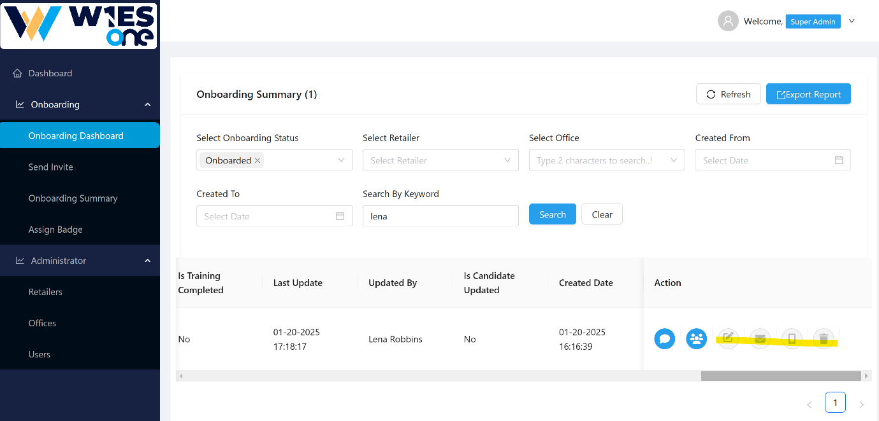

Copy link option isnt available – **For retailer onboard we don’t have copy link option. – P1**

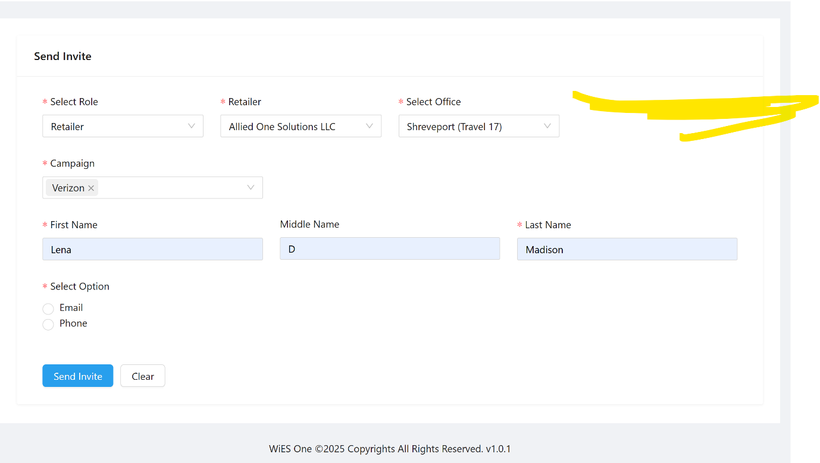

Flow we would use internal to manage agents

How do we get the ssn to pull a bgc? **Backend - P1**

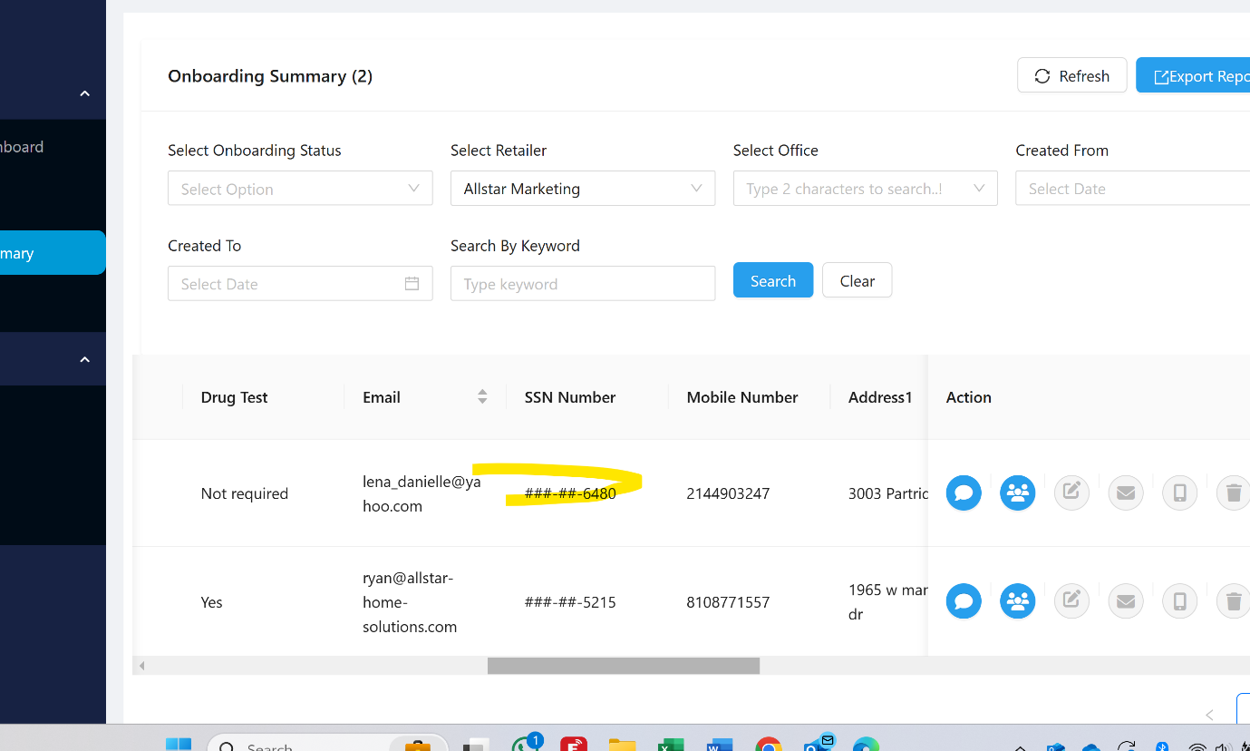

What is contract form – Yes we can remove this

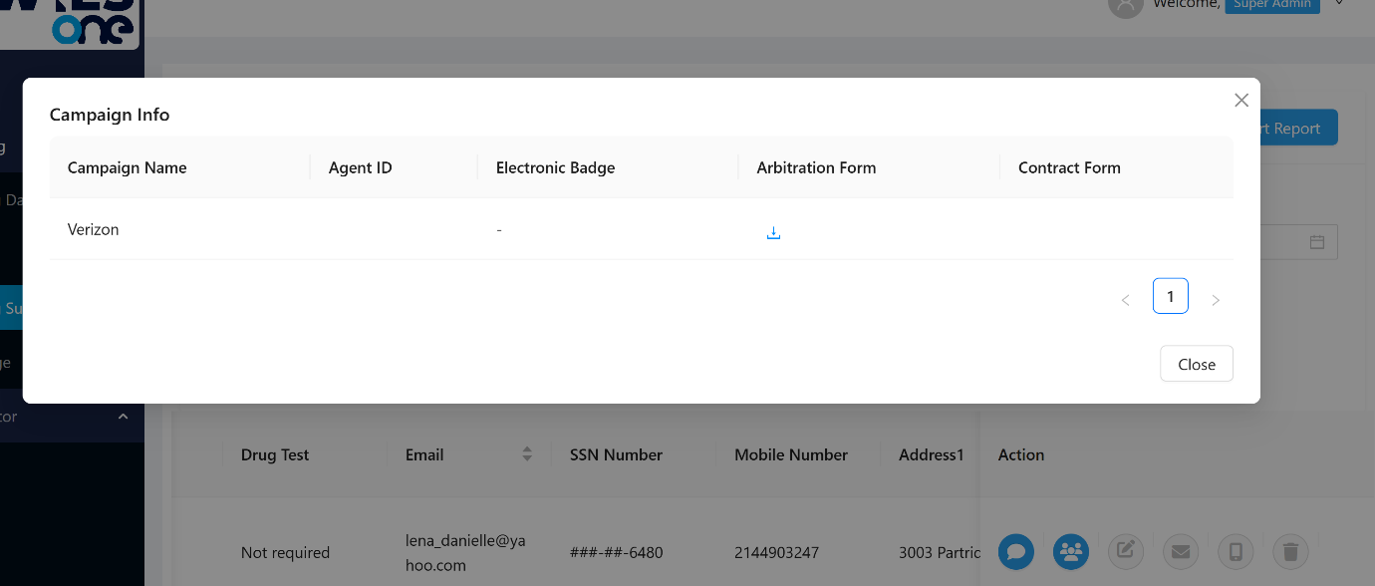

Drug test is not required on verizon- remove – **Both Backend and Frontend.**

**This should handle in Verify PII as well. Remove Drug test – P1**

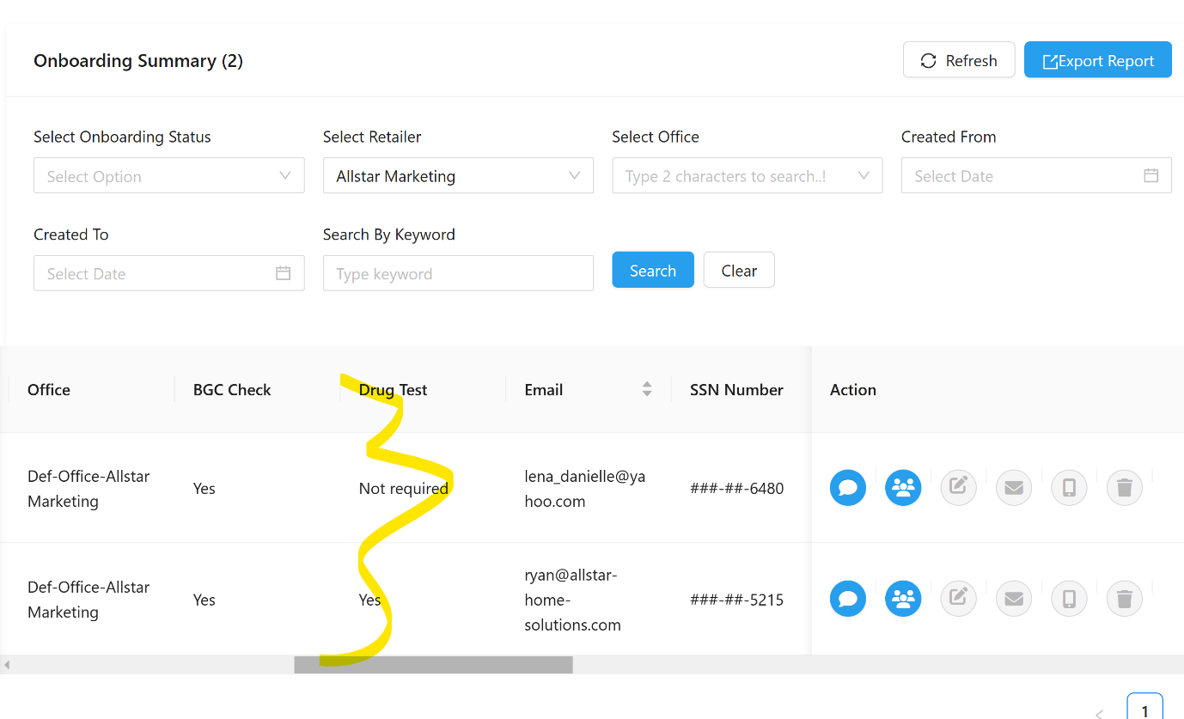

onboarding summary page

No offices numbers appearing? **Need to type atleast 2 characters – P2**

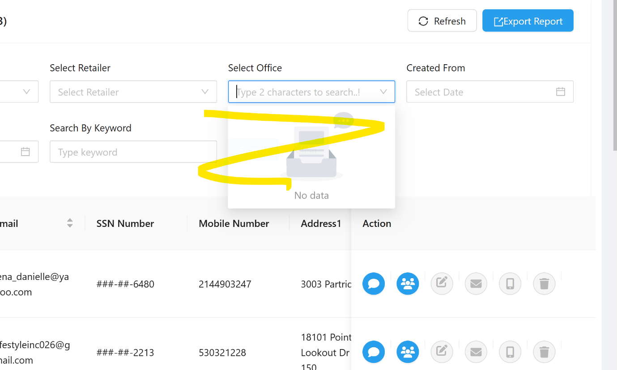

Assign badge page no offices ? **Need to type atleast 2 characters**

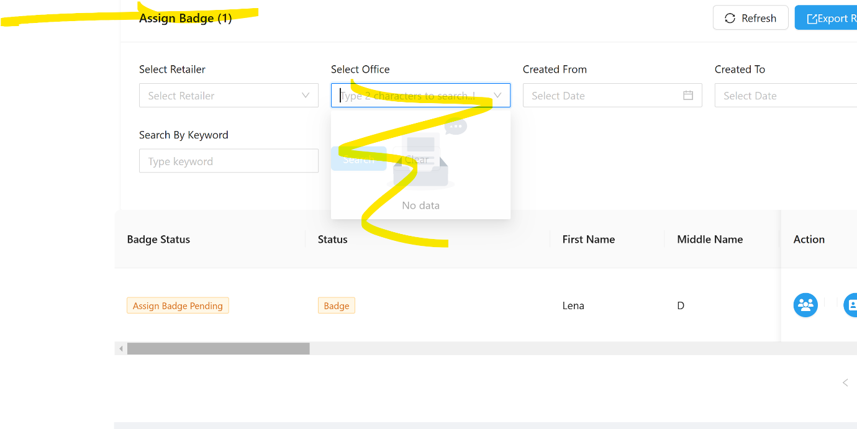

**\*\*\*\*\*\*\*\*\*\*\*\*\*\*\*\*\*\*\*\*\*\*\*\*After i assigned the badge number it said agent onboarded successfully- where do i see the email log of what was emailed to the agent? I didn't get any emails in my inbox** [**lena_danielle@yahoo.com\*\*\*\*\*\*\*\*\*\*\*\*\*\*\*\*\*\*\*\*\*\*\*\*\*\*\*\*\*\*\*\*\*\*\*\***](mailto:lena_danielle@yahoo.com************************************) **Check spam**

Why are these gray- i can't edit anything as the admin **Frontend**

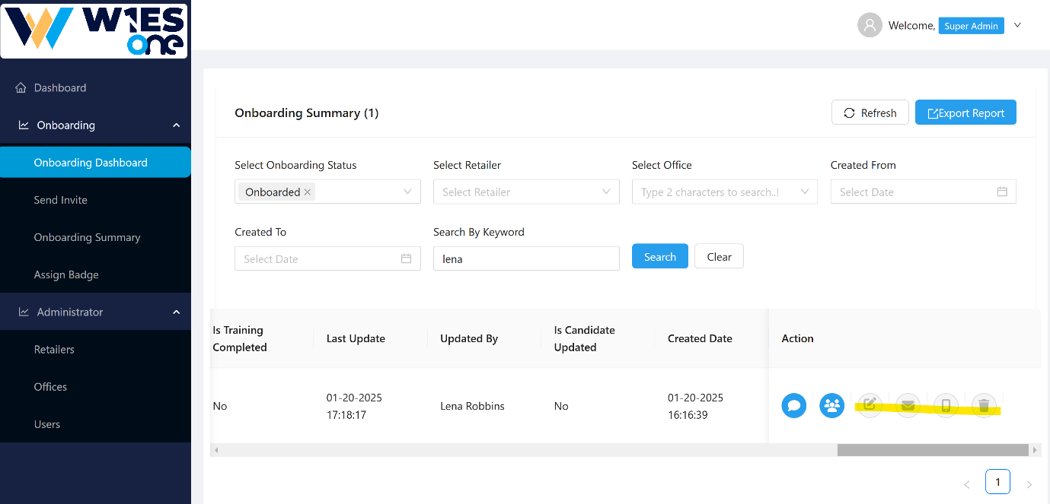

Where is a copy of the badge? I clicked on my name under onboarded agents.  
It will be available in the Get campaign info section in the dropdown. But still, we can add here

